Quiz 1 ***(CSE331L.7 – Asif Ahmed Neloy_Summer’20)***

Department of Electrical and Computer Engineering

School of Engineering and Physical Sciences

North South University, Bashundhara, Dhaka-1229, Bangladesh

*Time 20 minutes, Marks 20 (You need to answer all questions).*

***Name -***

***ID - 5/10***

1. **Why it is never a good idea to store any data in the segment registers?[5]**

**Answer: Mainly data or code store in the data segment memory but data segment registers use for store data segment memory address. So, it is not a good idea to store data in the segment registers.**

1. **Write a program in Assembly language that will add 4 integer number (1,2,2,1) using only AX register and Store the result in the AX register.**

**CODE?**

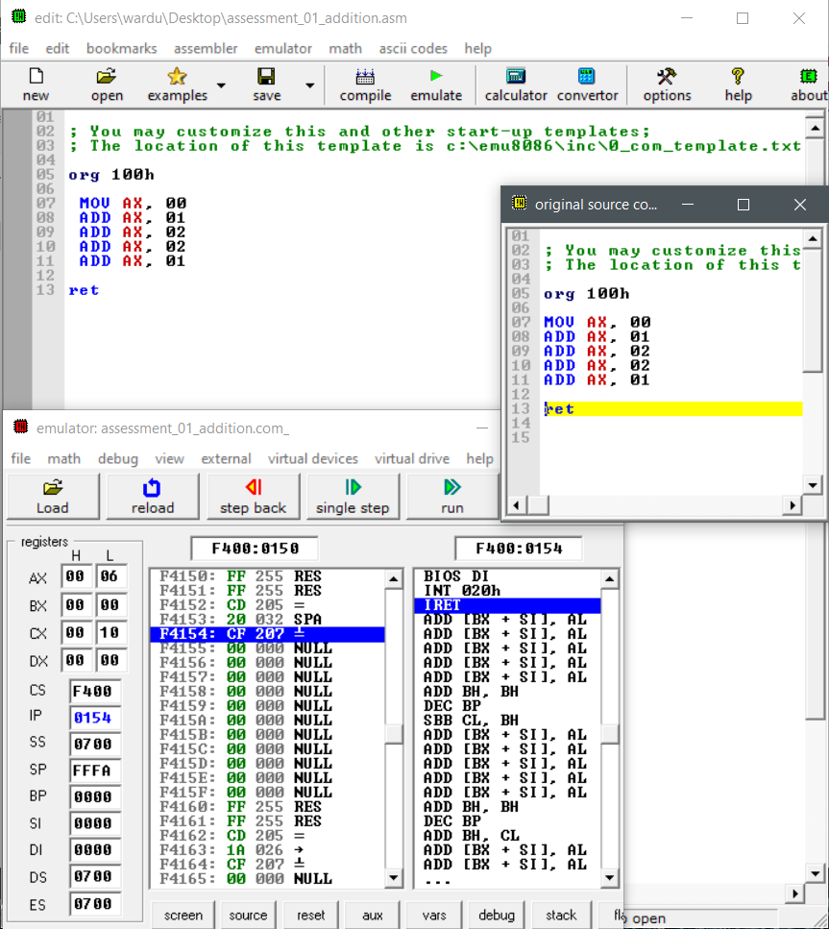

**End**